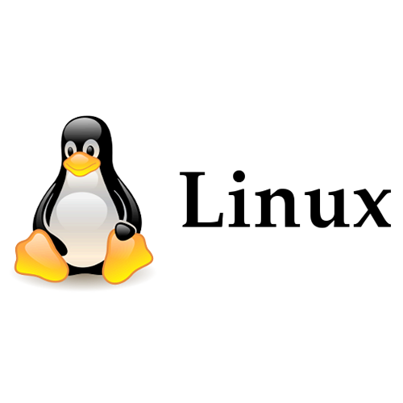

Linux Server

Linux Server - Control Access

1. Manage users and groups with commands like useradd, userdel, groupadd, and passwd.

A:

sudo useradd [options] username

sudo userdel [options] username

sudo groupadd groupname

sudo passwd username

2. Explain File Permission groups in Linux?

A: File permissions are categorized into three groups: Owner, Group, and Others. Each group can have Read (r), Write (w), and Execute (x) permissions.

3. What are the kinds of permissions under Linux?

A: Read(R), Write (W), Execute(X)

4. What is Selinux Security?

A: SELinux is a security feature in Linux that controls how programs and users access files and resources. It uses rules to restrict what actions can be taken, providing an extra layer of protection against unauthorized access or actions.